EXERCISE 4: EMPLOYEE MANAGEMENT SYSTEM

Name: Shubham Sangram Bej
AIM
To implement an Employee Management System using arrays and perform add, search, traverse, and delete operations on employee records.
INTRODUCTION
Arrays are one of the most fundamental data structures used in programming. They store elements of the same data type in contiguous memory locations. Arrays provide efficient access to elements using an index and are widely used when the number of elements is known in advance.
ARRAY REPRESENTATION IN MEMORY
An array is stored as a contiguous block of memory. Each element occupies a fixed amount of memory, and the address of any element can be calculated using the base address and its index.
Advantages of Arrays
- Fast Access
Elements can be accessed directly using an index in O(1) time.
- Memory Efficient
Arrays require minimal memory overhead because elements are stored continuously.
- Simplicity
Arrays are easy to implement and understand.
EMPLOYEE CLASS
The Employee class contains the following attributes:
• employeeId
• employeeName
• designation
• salary
Each employee object stores information about an employee working in the organisation.

IMPLEMENTATION
The Employee Management System performs the following operations:
- Add Employee
A new employee is inserted into the next available position in the array.
- Search Employee
The system searches for an employee using the Employee ID.
- Traverse Employees
All employee records stored in the array are displayed.
- Delete Employee
The employee is removed, and the remaining elements are shifted left to maintain continuity.
TIME COMPLEXITY ANALYSIS
Add Operation
Time Complexity: O(1)
Reason:
The employee is inserted directly at the next available index.
Search Operation
Time Complexity: O(n)
Reason:
The entire array may need to be traversed to find the employee.
Traverse Operation
Time Complexity: O(n)
Reason:
Every employee record is visited exactly once.
Delete Operation
Time Complexity: O(n)
Reason:
After deleting an employee, the remaining elements must be shifted.
SUMMARY TABLE
Operation Time Complexity
Add : O(1)
Search: O(n)
Traverse: O(n)
Delete: O(n)

LIMITATIONS OF ARRAYS
- Fixed Size
The size of an array cannot be changed after creation.
- Costly Deletion
Deleting elements requires shifting remaining elements.
- Linear Search
Searching requires traversing the array.
- Memory Allocation
Unused array locations still consume memory.
WHEN TO USE ARRAYS
Arrays should be used when:
• The number of records is known in advance.
• Fast index-based access is required.
• The dataset size is relatively small.
• Frequent insertions and deletions are not required.
OUTPUT
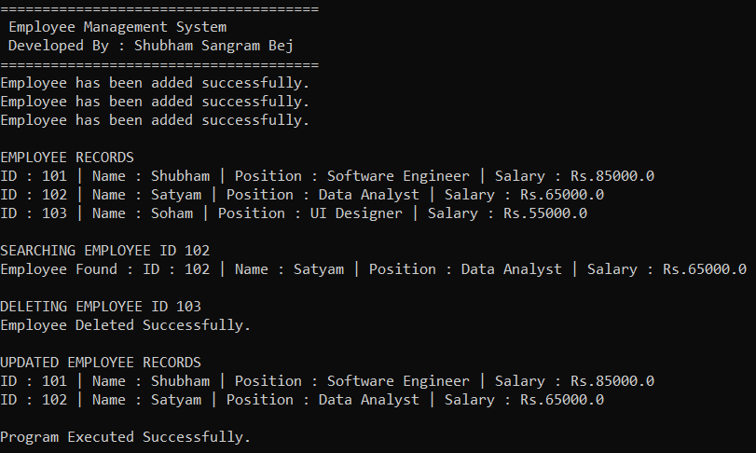
RESULT
The Employee Management System was successfully implemented using arrays. Employee records were added, searched, traversed, and deleted successfully.

CONCLUSION
This exercise demonstrated the use of arrays for storing and managing employee records. Arrays provide efficient access and simple implementation, but suffer from fixed-size limitations and costly deletion operations. They are best suited for applications where the amount of data is relatively stable.

